
Shamsi School
Shamsi Society Campus (Boys’ Shift)
Final Examination (2024-25)
Class: V
Subject: Mathematics

Name: __________________Sec: ____Roll #: _____ Invigilator’s Sign: ___ T.Marks: 100

OBJECTIVE Max. Marks: 20
Q.1) What are the missing numbers? /03
- 2 : 5 = _______ : 10
- 9 : 12 : = 3 : ______
- 3 : 12 : 18 = -1: _______ : _______
- 10 : 8 : 12 = ______ : 4 : _______
Q.2) Convert: /05
- 0.83 m = ________ cm
- 6.6 Km = ________ m
- 559 cm = ________ m
- 3016 m = _______ Km
- 0.09 Kg = ________ g
Q.3) Express each of the following as a percentage. /02
- $\frac{6}{100}$ = ______ %
- $\frac{70}{100}$ = ______ %
- $\frac{3}{10}$ = _______ %
- $\frac{5}{10}$ = _______ %
Q.4) Identify each of the following triangle. /02

- (b) (c) (d)

- _______________________ (c) ________________________
- = _____________________ (d) _______________________
Q.5) Name the triangles. /02
- A triangle with a right angle = _________________
- A triangle that has three equal sides = ___________
- A triangle that has two equal sides = ____________
A triangle that has an obtuse angle = ____________

Q.6) Identify each of the following 4- sided figures. Explain your answers. /4.5

- (b)

ANS:_________________________________ ANS: _______________________________

- (d)

ANS:_________________________________ ANS: _______________________________

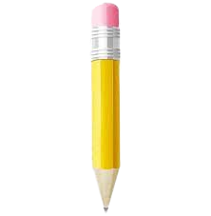
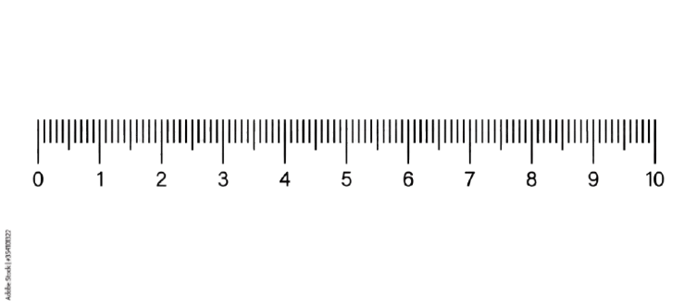 Q.3) /1.5


PENCIL
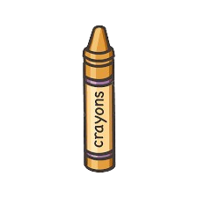
ERASER

CRAYON

The ratio of the length of the crayon to the length of the eraser to the length of the pencil is
__________ : ________ : _________


Shamsi School
Shamsi Society Campus (Boys’ Shift)
Final Examination (2024-25)
Subject: Mathematics
SUBJECTIVE Max. Marks:80

Q.1) Multiply them: ( any four ) /08
- $\frac{2}{5}$ × $\frac{1}{4}$ b) 2 $\frac{1}{5}$ × 5
- 1.12 × 1000 d) 0.38 × 2000
- 1.027 × 40 f) 3.82 × 90
Q.2) Divide them: ( any four ) /08
a) 25.3 ÷ 10 b) 24.9 ÷ 100
c) 41 ÷ 1000 d) 768 ÷ 6000
e) 2.1 ÷ 70 f) 0.56 ÷ 80
Q.3) Express each of the following as a percentage: /06
- 0.02 b) 0.08 c) 0.62
Q.4) Find the value of each of the following: /06
- 15% of 20 b) 5% of 960
- 60% of 300 d) 85% of 60
Q.5) Express each of the following as a decimal : /06
a) 17% b) 9% c) 30%
Q.6) Express the following in minutes: /06
a) $\frac{3}{4}$ hr b) 5 $\frac{8}{15}$ hr c) 1 $\frac{7}{10}$ hr

Q.7) A class has 20 girls and 16 boys 30% of the girls go to school by bus. How many girls in the class go to school by bus? /03

Q.8) 2.48 Kg of flour is mixed with 1.27 LG of sugar. The mixture is then packed equally into 15 packets. What is the mass of each packet in Kg? /03

Q.9) A dress costs $ 54. Late buys the dress at a discount of 28%. How much does Kate pay for the dress? /03

ALGEBRA SECTION
Q10) Find the value of ‘y’: ( any four ) /08
- 5y + 15 = 64 (iv) 12 y – 15 = 45
- 9y = 72 (v) 3y = 27
- 7y + 9 = 44
Q11) Write an algebric expression for each of the following. /04
- Add 5 to a (iii) Subtract from 7
- 4 more than c (iv) 6 less than 9
Q12) Bala is ‘t’ year old now. Bala’s cousin is twice as old as Bala. How was Bala’s cousin 2 years age? /03
GEOMETRY SECTION
Q12) Write definition of the following ( any two ) /04
- Equilateral triangle (iii) Scalene triangle
- Isosceles triangle
Q13) Draw each of the following triangles. /04
- Triangle ABC where BC = 6cm, AB = 7cm and ∠ABC = 110 °
OR
Find the unknown angle in each triangle.
- (ii)

Q14) Draw each of the following four – sided figures. /04
- Parallelogram EFGH, where EF = 5 cm, FG = 3 cm and ∠EHG = 70 °

Q15) Find the unknown marked angles in each parellelogram. /04
- (ii)

